IPv4 Packet Structure
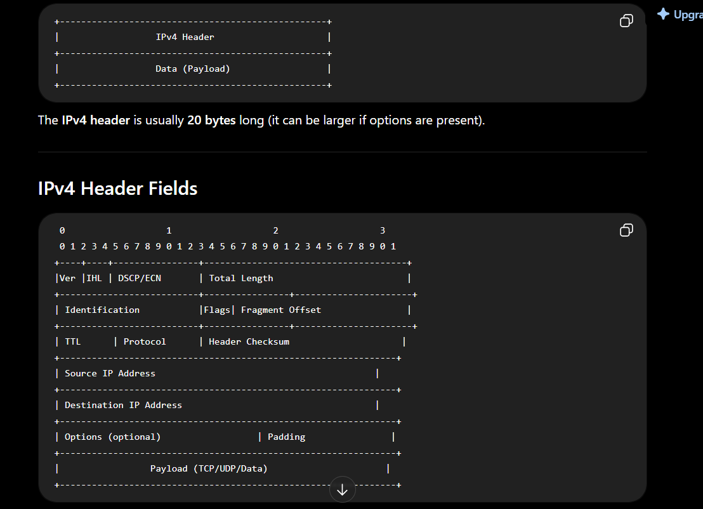

The fields you should know
Field | Purpose
Version | IP version (4 for IPv4).
IHL (Internet Header Length) | Size of the IPv4 header. Normally 20 bytes.
Total Length | Total size of the packet (header + data).
Identification | Identifies fragments of the same packet.
Flags | Controls fragmentation (e.g., Don't Fragment).
Fragment Offset | Position of a fragment in the original packet.
TTL (Time To Live) | Prevents packets from looping forever. Decreased by 1 at each router.
Protocol | Indicates the next-layer protocol (TCP, UDP, ICMP, etc.).
Header Checksum | Detects errors in the IPv4 header only.
Source IP Address | Sender's IP address.
Destination IP Address | Receiver's IP address.
Options | Optional extra information (rarely used).

The most important fields for beginners
If you're studying networking or cybersecurity, these are the ones you should recognize immediately:

1. Source IP
Example:
192.168.1.10
The sender's IP address.

2. Destination IP
Example:
8.8.8.8
The destination IP address.

3. TTL (Time To Live)
Example:
TTL = 64
Every router decreases it by 1.
If it reaches 0:
➡️ The router drops the packet and usually sends back an ICMP Time Exceeded message.

4. Protocol
This tells IPv4 what's inside the payload.
Value | Protocol
1 | ICMP
6 | TCP
17 | UDP
Example:
Protocol: TCP (6)
means the IPv4 payload contains a TCP segment.

5. Total Length
Indicates the total size of the IPv4 packet.
Example:
Total Length = 60 bytes

6. Header Checksum
Checks whether the IPv4 header was corrupted during transmission.
Important: It checks only the IPv4 header, not the payload.

Example in Wireshark
When you expand the Internet Protocol Version 4 section, you'll see something like:
Internet Protocol Version 4
Version: 4
Header Length: 20 bytes
Total Length: 60
Identification: 0x1234
TTL: 64
Protocol: TCP (6)
Header Checksum: 0xabcd
Source: 192.168.1.5
Destination: 10.10.41.192
You should be able to explain what each of these means.
DIFF BETWEEN FCS AND IPV4 CHECKSUM

Quick Comparison
Feature | FCS | IPv4 Header Checksum
Layer | Layer 2 (Data Link) | Layer 3 (Network)
Used in | Ethernet Frame | IPv4 Packet
Protects | Entire Ethernet frame (except the FCS field itself) | IPv4 header only
Algorithm | CRC (Cyclic Redundancy Check) | Internet Checksum (1's complement)
Stronger? | ✅ Yes | ❌ No
Recalculated by | Sender and receiver | Every router

Where are they located?

Ethernet Frame
+--------------------------------------------------------------+
| Ethernet Header | IPv4 Packet | FCS (Trailer) |
+--------------------------------------------------------------+
The FCS is the last field in the Ethernet frame.

IPv4 Packet
+------------------------------------------------------+
| IPv4 Header (Checksum) | TCP/UDP | Data |
+------------------------------------------------------+
The IPv4 checksum is inside the IPv4 header.

What does each one check?

FCS
Checks:
- Ethernet Header ✅
- IPv4 Header ✅
- TCP/UDP Header ✅
- Application Data ✅
Basically, it checks almost the entire Ethernet frame.

IPv4 Header Checksum
Checks only:
- Version
- TTL
- Source IP
- Destination IP
- Protocol
- All other IPv4 header fields
It does NOT check:
- TCP data ❌
- UDP data ❌
- HTTP request ❌
- Payload ❌

Why do we need both?
Imagine you're sending an HTTP request.
HTTP GET
│
TCP
│
IPv4
│
Ethernet

If one bit changes during transmission...

FCS
Detects:
"The Ethernet frame was corrupted."
The frame is discarded.

IPv4 Checksum
Detects:
"The IPv4 header itself is corrupted."
This protects routing information like:
- Source IP
- Destination IP
- TTL

Why do routers recalculate the IPv4 checksum?
Every router decreases the TTL by 1.
Example:
Before router:
TTL = 64
Checksum = 0xABCD
After router:
TTL = 63
Since the IPv4 header changed, the old checksum is no longer valid.
The router computes a new IPv4 header checksum before forwarding the packet.

Does the router recalculate the FCS?
Yes, but for a different reason.
When a router receives an Ethernet frame:
- It checks the incoming FCS.
- Removes the old Ethernet header and trailer.
- Processes the IPv4 packet.
- Creates a new Ethernet frame for the next network hop.
- Calculates a new FCS for that new frame.
So the FCS changes because a new Ethernet frame is built, not just because the TTL changed.

Easy way to remember
Think of mailing a package.
📦 Ethernet Frame = Shipping box
📄 IPv4 Packet = Letter inside the box
- FCS checks whether the entire box arrived without damage.
- IPv4 Header Checksum checks whether the address written on the letter is still correct.

